

Secure Cloud Infrastructure
Cloud Security Audit, IAM Hardening, Web Application Firewall Protection and Multi-Region Resilience
Assignment Report
Item | Detail
Prepared by | Tayyba Sarfraz
Programme | (internship task)
Task | Secure Cloud Infrastructure (Internee.pk)
Cloud platform | Amazon Web Services, eu-north-1 (Stockholm)
Report date | 28 October 2026
Version | 1.0 (final submission)
Evidence handling | AWS account identifiers and sign-in URLs redacted from all screenshots

Table of Contents

1. Executive Summary 3
2. Objectives, Scope and Methodology 4
2.1 Requirement Traceability 4
2.2 Approach and Evidence Standard 4
3. Environment and Architecture 5
4. Task 1: Cloud Account and Network Audit 6
4.1 Regional Resource Baseline 6
4.2 VPC Design and Segmentation 6
4.3 Findings 7
5. Task 2: Identity and Access Management 8
5.1 Group-Based Access Model 8
5.2 User Provisioning and Credential Handling 9
5.3 Findings and Hardened Policy Design 10
6. Task 3: Compute Access and Network Filtering 11
6.1 Key Pair Provisioning 11
6.2 Security Group Configuration 12
6.3 Findings 12
7. Task 4: Web Application Firewall 13
7.1 Design 13
7.2 Test Evidence 13
7.3 Log Analysis 14
7.4 Findings and AWS WAF Mapping 15
8. Task 5: Multi-Region Backup and Recovery 16
8.1 Design 17
8.2 Implementation Runbook 17
8.3 Restore Validation 18
9. Task 6: Logging, Monitoring and Data Sources 18
9.1 Event-to-Evidence Mapping 19
9.2 Monitoring Plan 19
10. Consolidated Findings and Risk Register 20
11. Compliance Mapping 21
12. Remediation Roadmap 22
13. Limitations and Evidence Statement 22
14. Conclusion 22
References 23
Appendix A: Evidence Index 24
Appendix B: Reference Policies and Backup Plan 25

1. Executive Summary
This report documents a security audit and hardening exercise for a cloud-hosted web platform of the kind operated by Internee.pk. The work was carried out in a representative lab environment named ShieldSafe on Amazon Web Services (AWS), region eu-north-1 (Stockholm), together with a separate virtual lab in which a custom Web Application Firewall (WAF) was built and attacked under controlled conditions. No production data or production accounts were used.
The assignment set three requirements: audit cloud accounts for security compliance; apply IAM policies and set up multi-region backups; and enable a WAF to filter and monitor external traffic. The work was organised into six tasks, each supported by numbered screenshot evidence, and each task ends with findings that are rated, mapped to ISO/IEC 27001:2022 and NIST CSF 2.0, and assigned a remediation action.

Outcome against the three requirements
Requirement | What was done and shown | Status
1. Audit the cloud account for security compliance | AWS network, IAM, key-pair and security-group configuration audited from console evidence (Figures 2 to 11); 12 findings raised and rated. | Evidenced
2a. Apply IAM policies | Two IAM groups, two users, managed policy attachment and forced password reset configured (Figures 5 to 9); over-privilege identified and a least-privilege replacement policy designed. | Evidenced
2b. Set up multi-region backups | Cross-region design (eu-north-1 to eu-west-1), vault, KMS, lock and restore-test runbook produced. Execution is not shown in the screenshots. | Designed, not executed
3. Enable a WAF to filter and monitor traffic | Custom reverse-proxy WAF blocked SQL injection and XSS, allowed benign traffic and logged rule IDs and scores (Figures 12 to 17). It ran in a local lab, not behind AWS WAF. | Evidenced
Data sources (CloudTrail, Monitor, GCP Logging) | WAF log analysed; CloudTrail event-to-evidence mapping and monitoring plan defined. No CloudTrail export is included. | Partially evidenced

Headline results
- Strengths. A dedicated VPC with separate public and private subnets; group-based (not user-attached) permissions; auto-generated console passwords with forced reset; an anomaly-scoring WAF that blocked boolean SQL injection, UNION-based SQL injection and reflected XSS while a benign request succeeded.
- Highest-priority weaknesses. AdministratorAccess is attached to both IAM groups (F-01); MFA is not evidenced for any identity (F-02); no cross-region backup or restore test is evidenced (F-03).
- Evidence discipline. Claims are limited to what the screenshots show. MFA, cross-region backup, CloudTrail exports and an AWS-managed WAF are classed as gaps or designs, not as completed controls, so every rating can be defended in review.
- Overall posture. Foundation controls are sound for a lab; the environment is not yet production-ready until F-01 to F-03 are closed.

2. Objectives, Scope and Methodology
Objective. Ensure that cloud-based platforms follow industry-standard security measures, by auditing configuration, applying identity controls and resilience measures, and filtering and monitoring external web traffic.
Scope. AWS was selected as the audited platform; the task permits AWS, GCP or Azure. In scope: VPC and subnet design, IAM groups and users, EC2 key pairs, security groups, a custom WAF against the DVWA application, logging sources, and backup and recovery design. Out of scope: production workloads, Azure and GCP tenancies, and penetration testing of any system the author does not own.

2.1 Requirement Traceability
The matrix links each stated requirement to the task in this report, the evidence that supports it and its status.
Requirement (from brief) | Report task | Evidence | Status
Audit cloud accounts for security compliance | Tasks 1, 2, 3 | Figures 2 to 11 (VPC, IAM, key pair, security group) | Evidenced
Apply IAM policies | Task 2 | Figures 5 to 9; policy design in Appendix B | Evidenced
Set up multi-region backups | Task 5 | Design and runbook only; Appendix B backup plan | Designed, not executed
Enable WAF to filter and monitor external traffic | Task 4 | Figures 12 to 17 (custom WAF lab) | Evidenced
Use cloud security logs as data | Task 6 | Figure 16 (WAF log); CloudTrail mapping table | Partially evidenced
Use public datasets (AWS Open Data) | Task 6 | Not used; stated in Section 13 | Gap

2.2 Approach and Evidence Standard
The assessment is evidence-led. Each configuration claim cites a figure; anything not visible in a figure is either removed or labelled as designed or unverified. Findings are scored with a 5 by 5 matrix (likelihood 1 to 5 multiplied by impact 1 to 5). A score of 12 or more is High, 6 to 11 is Medium, and 5 or less is Low. Controls are mapped to ISO/IEC 27001:2022 Annex A and NIST CSF 2.0 functions in Section 11.
Account identifiers, owner IDs and console sign-in URLs were redacted from the screenshots before inclusion, in line with the principle that evidence must not itself create exposure.

How to read the status labels
Evidenced: visible in a screenshot in this report. Partially evidenced: some elements visible, others not.
Designed, not executed: a specified design and runbook; no screenshot shows it was run. Gap: required but neither shown nor designed.

3. Environment and Architecture
The environment has two parts that together exercise every requirement. The AWS part provides the identity, network and compute foundation. The WAF lab provides a working web-traffic filter. Figure 1 shows both; solid outlines are evidenced and dashed outlines are proposed designs.
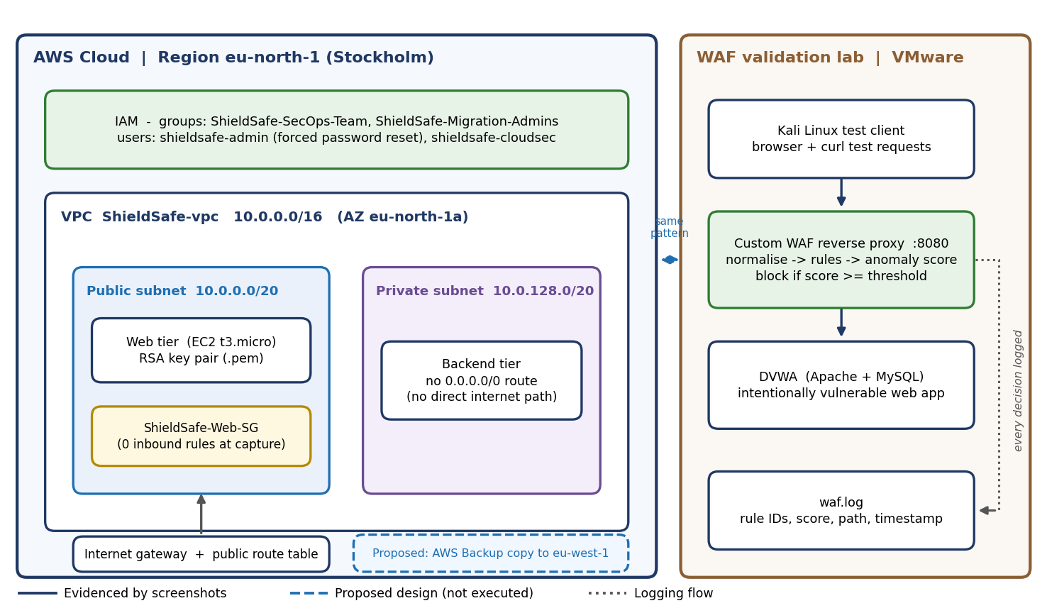
Figure 1. ShieldSafe architecture: AWS foundation (left), WAF validation lab (right), and proposed controls shown dashed.
The ShieldSafe environment is a representative model of an Internee.pk-style platform (public web tier, private backend, administrator access and an internet-facing application). It demonstrates how the required controls are applied; it is not Internee.pk’s production account.
Component | Observed configuration | Source
Region and AZ | eu-north-1 (Stockholm), AZ eu-north-1a | Figures 2, 4
VPC | ShieldSafe-vpc, 10.0.0.0/16, state Available, DNS resolution and hostnames enabled | Figure 4
Subnets | Public 10.0.0.0/20; private 10.0.128.0/20 | Figure 3
Routing | Public route table with 0.0.0.0/0 to the internet gateway; separate private route table | Figures 3, 4
IAM | Groups ShieldSafe-SecOps-Team and ShieldSafe-Migration-Admins; users shieldsafe-admin and shieldsafe-cloudsec | Figures 5 to 9
Compute access | EC2 launch with t3.micro and an RSA .pem key pair | Figure 10
Network filter | Security group ShieldSafe-Web-SG, 2 outbound entries, 0 inbound entries at capture | Figure 11
WAF lab | Kali Linux VM (VMware Workstation), WAF proxy on 192.168.1.26:8080 in front of DVWA | Figures 12 to 17

4. Task 1: Cloud Account and Network Audit
Purpose. Establish what exists in the cloud account and judge whether the network foundation isolates workloads. An inventory comes first: a control cannot be assessed on a resource nobody has listed.

4.1 Regional Resource Baseline
The VPC dashboard for Europe (Stockholm) gives a regional inventory (Figure 2): 1 VPC, 3 subnets, 1 route table, 1 internet gateway, 1 network ACL, and zero NAT gateways, VPC peering connections and endpoint services.
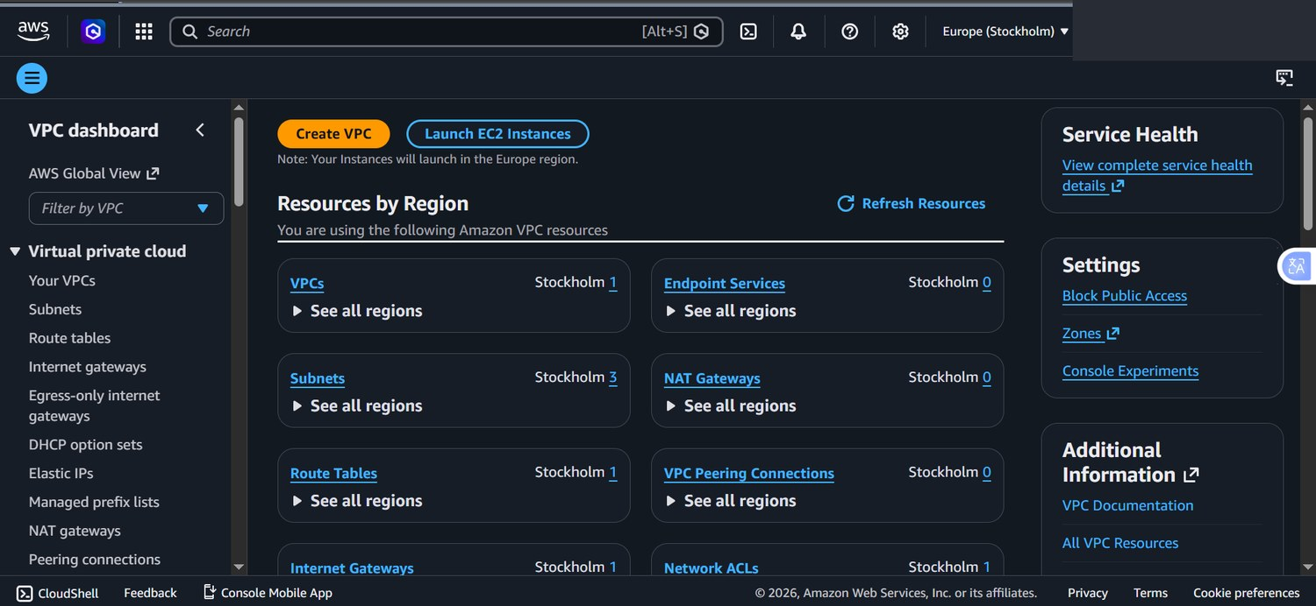
Figure 2. VPC dashboard, Europe (Stockholm): regional resource inventory used as the audit baseline.
Zero peering connections and zero endpoint services mean there are no unplanned network paths into or out of the VPC, which keeps the attack surface small. This snapshot came from a separate console session, so its counts are reported as a regional baseline and are not merged with the ShieldSafe resource map below.

4.2 VPC Design and Segmentation
The VPC was built with the console wizard. The preview (Figure 3) shows a 10.0.0.0/16 network with a public subnet (10.0.0.0/20) and a private subnet (10.0.128.0/20) in eu-north-1a. Only the public route table carries a default route (0.0.0.0/0) to the internet gateway.
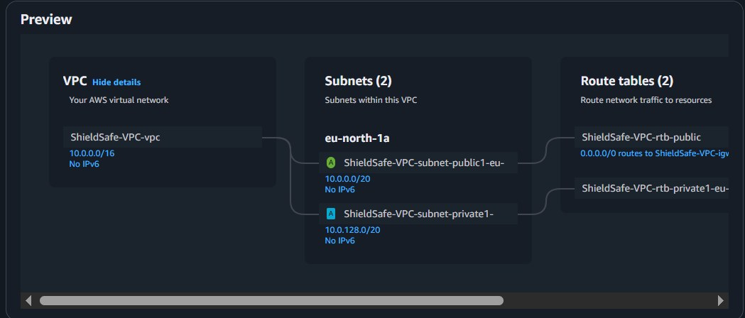
Figure 3. VPC creation preview: CIDR, subnets and route tables. The default route to the internet gateway appears on the public route table.
The created VPC (Figure 4) is named ShieldSafe-vpc, is Available, uses default tenancy, is not the default VPC, and has DNS resolution and DNS hostnames enabled. Its resource map lists two subnets, three route tables and one network connection (ShieldSafe-igw).
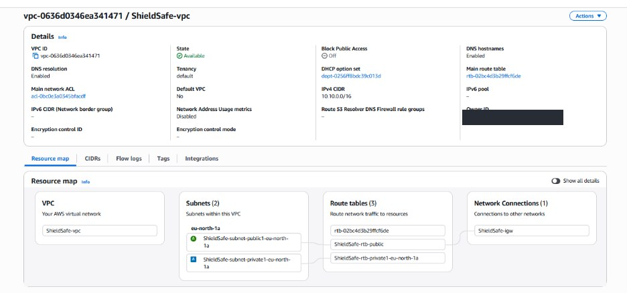
Figure 4. ShieldSafe-vpc details and resource map; owner identifier redacted.
Attribute | Observed | Security meaning
CIDR / subnets | 10.0.0.0/16; /20 public and /20 private | 4,096 addresses per subnet (4,091 usable); room to add tiers without re-addressing.
Public route table | 0.0.0.0/0 to internet gateway | Intended entry path for the web tier only.
Private route table | No internet route shown | Backend cannot be reached from or reach the internet directly.
Block Public Access | Off | Expected here: turning it on would block the internet gateway path the public tier needs.
Flow logs tab | Present; no log shown | Network-level logging is not evidenced (see F-05).

Address reconciliation
The VPC CIDR shown in the console is 10.0.0.0/16. The private subnet spans 10.0.128.0 to 10.0.143.255, so a backend address such as 10.0.142.100 recorded in working notes is valid and sits inside the private subnet and the VPC range. Network identifiers in this report are taken from the console figures only.

4.3 Findings
ID | Finding | Evidence | Rating | Remediation
F-12 | Both subnets are in a single Availability Zone (eu-north-1a); an AZ outage would take down every tier, and an internet-facing ALB needs two AZs. | Fig 4 | Medium | Add a public and a private subnet in a second AZ; deploy the web tier across both.
F-10 | Private subnet has no defined egress or patching path (no NAT gateway, no VPC endpoints evidenced). | Fig 3, 4 | Low | Use VPC endpoints (SSM, S3) or a NAT gateway with restricted routes; patch via Systems Manager Patch Manager.
F-05 | (Part) VPC Flow Logs are not evidenced, so accepted and rejected traffic cannot be reviewed. | Fig 4 | Medium | Enable flow logs to CloudWatch Logs or S3 with 90-day minimum retention.

Strength S-1. Segmentation by subnet and route table is the correct foundation (ISO/IEC 27001 A.8.22). The design is sound; the open items are about observability, not structure.

5. Task 2: Identity and Access Management
Purpose. Apply IAM policies so that people and workloads receive only the access they need. Identity is the new perimeter in the cloud: a stolen administrator credential defeats every network control.

5.1 Group-Based Access Model
Permissions were assigned through groups rather than attached to individual users, which is the AWS-recommended pattern because access can be reviewed and revoked in one place. Group ShieldSafe-SecOps-Team was created first (Figure 5).
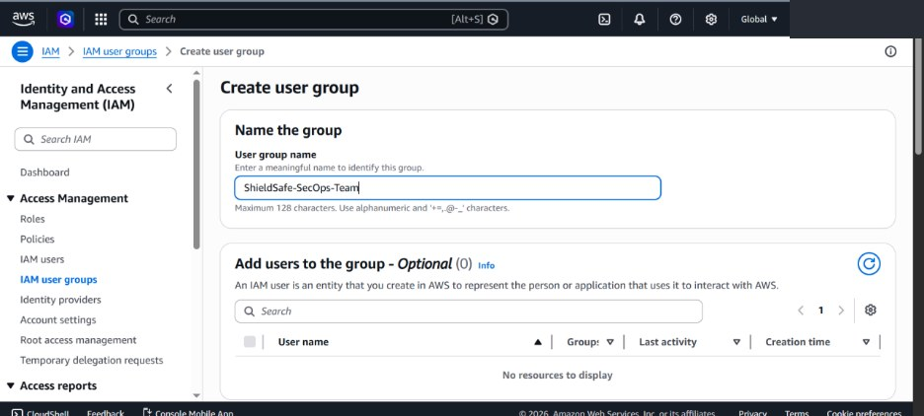
Figure 5. IAM user group creation: ShieldSafe-SecOps-Team.
During user creation, the permissions step lists the group with 0 members and the managed policy AdministratorAccess attached (Figure 6). A second group, ShieldSafe-Migration-Admins, was created with AdministratorAccess selected from 1,151 available policies (Figure 7).
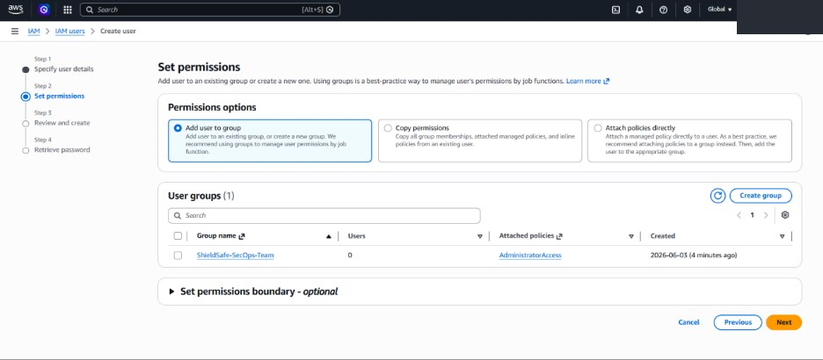
Figure 6. User creation, Set permissions step: "Add user to group" selected; group shows AdministratorAccess attached.
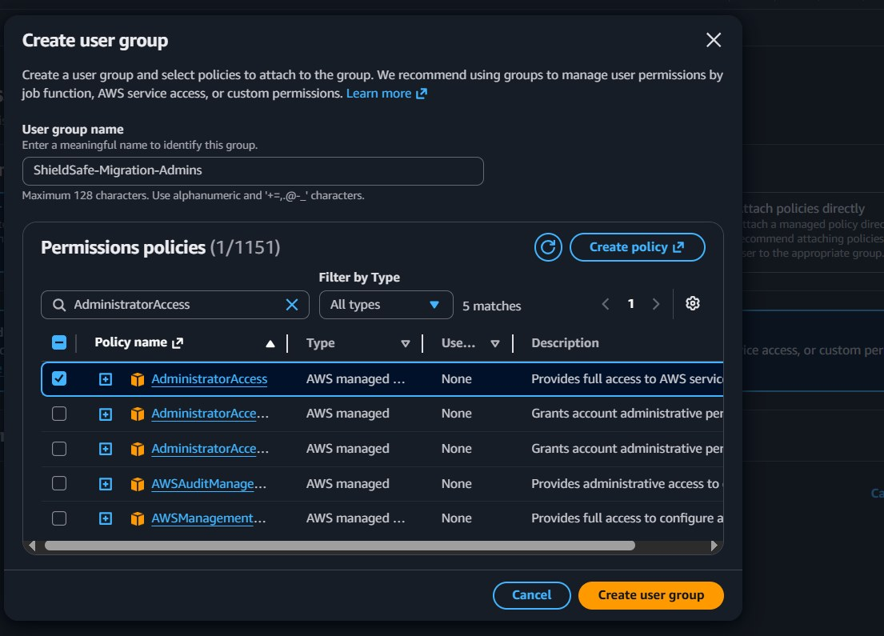
Figure 7. Creating ShieldSafe-Migration-Admins with the AdministratorAccess managed policy selected.
Assessment. Group-based assignment is correct; the policy chosen is not. AdministratorAccess grants every action on every resource, which violates least privilege (ISO/IEC 27001 A.8.2 and NIST CSF PR.AA). Two groups with the same policy also blur separation of duties (F-01, F-09).

5.2 User Provisioning and Credential Handling
User shieldsafe-admin was created with an auto-generated console password and Require password reset = Yes. Its permissions summary shows the managed policy IAMUserChangePassword and membership of ShieldSafe-Migration-Admins (Figure 8).
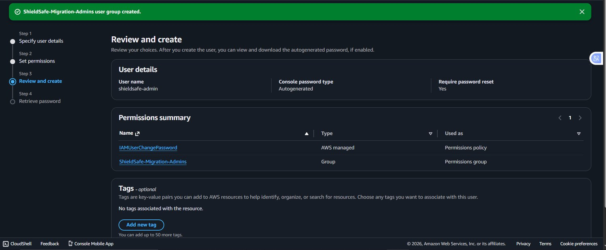
Figure 8. Review step for shieldsafe-admin: autogenerated password, forced reset, group membership.
User shieldsafe-cloudsec was then created and the console sign-in details retrieved (Figure 9). The console warns that this is the only time the password can be viewed or downloaded, so distribution must be secure; the sign-in URL is redacted in the figure.
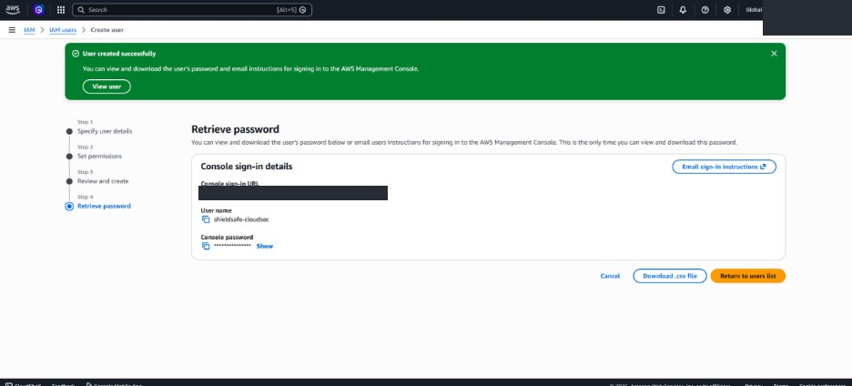
Figure 9. User created successfully; one-time credential retrieval for shieldsafe-cloudsec (sign-in URL redacted).
Assessment. Forced reset and self-service password change are good practice (S-3). No screenshot shows an MFA device assigned to any user or the root account, so MFA is treated as a gap, not a control (F-02).

5.3 Findings and Hardened Policy Design
ID | Finding | Evidence | Rating | Remediation
F-01 | AdministratorAccess is attached to both IAM groups; every member has unrestricted rights. | Fig 6, 7 | High | Replace with a scoped deployment policy and a permissions boundary (Appendix B, Policy 1). Reserve full admin for a break-glass identity.
F-02 | MFA is not evidenced for the root account, shieldsafe-admin or shieldsafe-cloudsec. | Fig 8, 9 | High | Enable MFA on root and every user; enforce with a deny-without-MFA policy (Appendix B, Policy 2).
F-09 | Two groups hold the same policy; SecOps-Team had no members, so roles are not separated. | Fig 5, 6 | Low | Give each group a distinct purpose (table below) and review membership quarterly.

Target access model. The table redefines the two existing groups so each has a distinct, minimal purpose.
Group / identity | Purpose | Proposed permissions
ShieldSafe-SecOps-Team | Security monitoring and audit | Managed policies SecurityAudit and ReadOnlyAccess; no write access to production resources.
ShieldSafe-Migration-Admins | Deployment and migration | Scoped policy limited to approved regions and services, with a permissions boundary (Appendix B).
Break-glass administrator | Emergency recovery only | Full access, hardware MFA, credentials sealed, every use alerted.
Root account | Account-level tasks only | No access keys; MFA enabled; not used for daily work.

Supporting hygiene. Set a password policy of at least 14 characters; rotate access keys at most every 90 days; generate the IAM credential report monthly and disable unused credentials; run IAM Access Analyzer to detect unintended external access.

6. Task 3: Compute Access and Network Filtering
Purpose. Control how administrators reach the web server and which traffic the web tier will accept.

6.1 Key Pair Provisioning
While launching the EC2 instance, a key pair was created (Figure 10): type RSA, private key format .pem for OpenSSH. The launch summary behind the dialog shows a t3.micro instance type and one 8 GiB volume. The console warns that the private key must be stored securely because it is needed to connect.
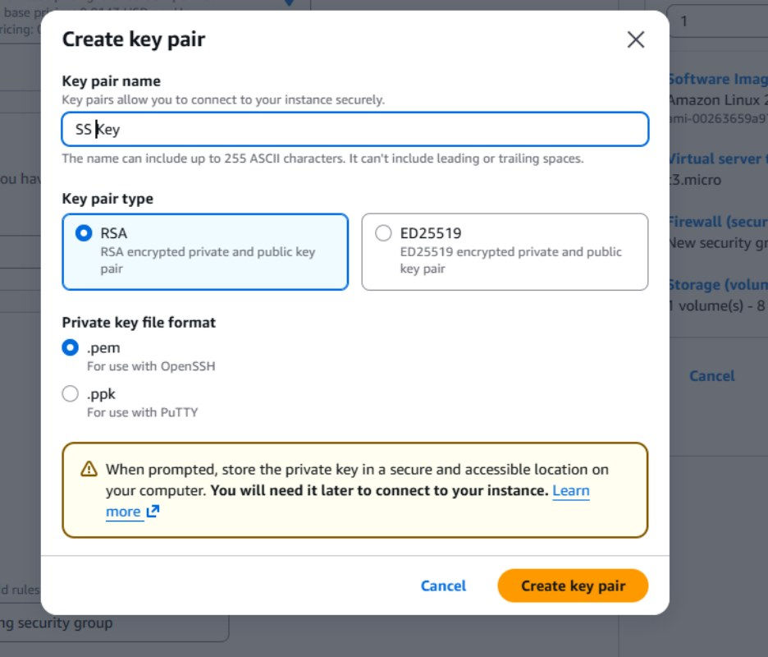
Figure 10. Create key pair dialog during EC2 launch: RSA, .pem format.
The private key is effectively the server’s password. It should be stored with owner-only permissions (chmod 400), kept out of source control, and rotated when staff change. ED25519 is a modern alternative with shorter keys; AWS Systems Manager Session Manager removes the need for open SSH access altogether (F-11).

6.2 Security Group Configuration
Security group ShieldSafe-Web-SG was created in ShieldSafe-vpc with the description “Allow HTTP and SSH traffic to web tier” (Figure 11). At capture time the Inbound rules count is 0 and outbound entries are 2.
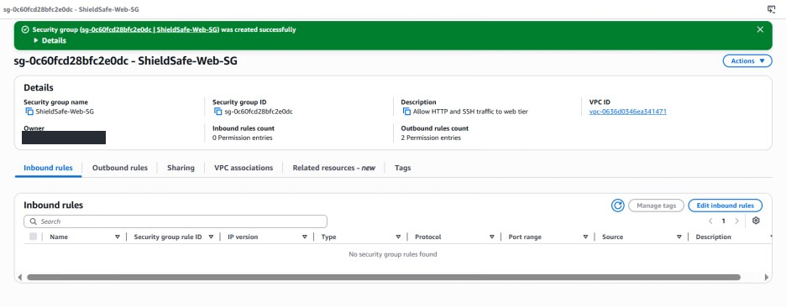
Figure 11. ShieldSafe-Web-SG created successfully; inbound rules list empty at capture; owner redacted.
Because security groups deny all inbound traffic by default, a group with no inbound rules admits nothing. The description records intent (HTTP and SSH) but the screenshot does not prove the rules were added. The target rule set below is proposed, not evidenced.
Rule (proposed) | Port | Source | Rationale
HTTPS | 443 | 0.0.0.0/0 | Encrypted public web traffic; certificate on load balancer or server.
HTTP | 80 | 0.0.0.0/0 | Redirect to HTTPS only; remove if not required.
SSH | 22 | Admin /32 address, or none | Restrict to a known administrator address; prefer Session Manager.
Backend DB port | Per service | Source = ShieldSafe-Web-SG | Only the web tier can reach the backend; no CIDR sources.
Outbound | 443, 53 | Required destinations | Replace allow-all egress with what the workload needs.

6.3 Findings
ID | Finding | Evidence | Rating | Remediation
F-04 | Web security group shows no inbound rules; intended HTTP and SSH rules are not evidenced or scoped. | Fig 11 | Medium | Apply the proposed rule set; restrict SSH to a /32 source or remove it.
F-08 | Only HTTP and SSH are named; no HTTPS listener or certificate is evidenced. | Fig 11 | Medium | Terminate TLS 1.2+ at an ALB with an ACM certificate; redirect port 80.
F-11 | RSA .pem private key must be protected; no storage or rotation control is shown. | Fig 10 | Low | Owner-only permissions, secrets vault storage, rotation at staff change; consider ED25519 or SSM.

7. Task 4: Web Application Firewall
Purpose. Filter and monitor external web traffic so that attacks are stopped before they reach the application, and so that every decision leaves a record. A WAF operates at the application layer (HTTP), where network firewalls and security groups cannot see SQL injection or cross-site scripting.

7.1 Design
The WAF was built as a reverse proxy that listens on port 8080 and forwards only clean requests to DVWA (Damn Vulnerable Web Application) running on Apache and MySQL. DVWA is intentionally insecure, which makes it a safe target for proving that the filter, and not the application, provides the protection. The proxy was implemented in Flask according to the project build notes.
Stage | Function | Observed in evidence
1 | Receive request on :8080 | All test URLs target 192.168.1.26:8080 (Figures 12 to 15).
2 | Normalise input | URL and HTML decoding and case folding (build notes); not visible in screenshots.
3 | Match rules | Rule IDs XSS-001, XSS-002, XSS-004, XSS-005 and 932100 appear in the log (Figure 16).
4 | Score | Matched rules add to an anomaly score: 13, 9 and 5 are visible (Figure 16).
5 | Decide | Blocked requests return the page "Request blocked by WAF" (Figures 13 to 15).
6 | Log | Each alert records timestamp, IP field, path, score and matched rules (Figure 16).

7.2 Test Evidence
Five request classes were sent from the Kali Linux client. The matrix records what the screenshots show; the figures follow.
# | Test | Request (from the browser address bar) | Observed result | Figure
T1 | Benign request | /dvwa/vulnerabilities/sqli/?id=1&Submit=Submit | Allowed; DVWA returned the ID 1 record (admin). | 12
T2 | Boolean SQL injection | ...sqli/?id=1’ OR ‘1’=‘1’&Submit=Submit | Blocked: "Request blocked by WAF". | 13
T3 | UNION SQL injection | ...sqli/?id=1 UNION SELECT username, password FROM users | Blocked: "Request blocked by WAF". | 14
T4 | Reflected XSS | ...xss_r/?name=<img src=x onerror=alert(1)> | Blocked: "Request blocked by WAF". | 15
T5 | Command injection | Requests to /dvwa/vulnerabilities/exec/ | Alerts with rule 932100 logged. | 16

T1: Legitimate traffic is allowed
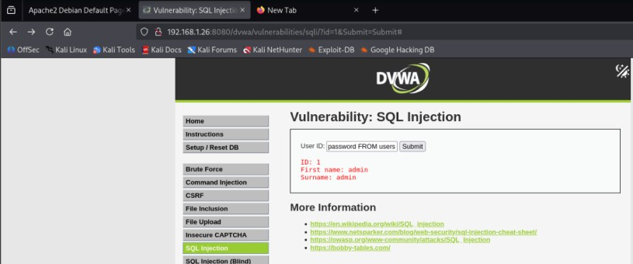
Figure 12. Benign SQL-injection-module request (id=1) passes through the WAF; DVWA returns the admin record.
A WAF that blocks everything is useless; this result shows the filter distinguishes normal use from attack.

T2 and T3: SQL injection is blocked
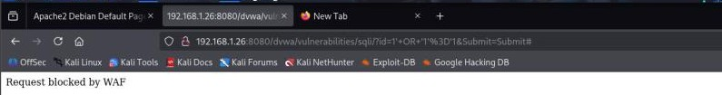
Figure 13. Boolean-based SQL injection (id=1’ OR ‘1’=‘1’) blocked by the WAF.
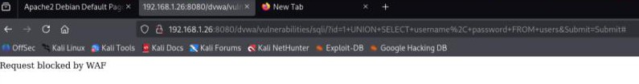
Figure 14. UNION-based SQL injection attempting to read usernames and passwords, blocked by the WAF.
Both techniques try to make the database return data the user should not see. Blocking them at the proxy means the vulnerable DVWA code never receives the malicious string.

T4: Reflected cross-site scripting is blocked
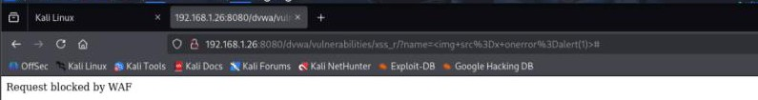
Figure 15. Reflected XSS payload using an image-tag onerror handler, blocked by the WAF.

7.3 Log Analysis
Monitoring is the second half of the requirement. The waf.log file (Figure 16) shows structured alert records, six of which are fully or partly visible.
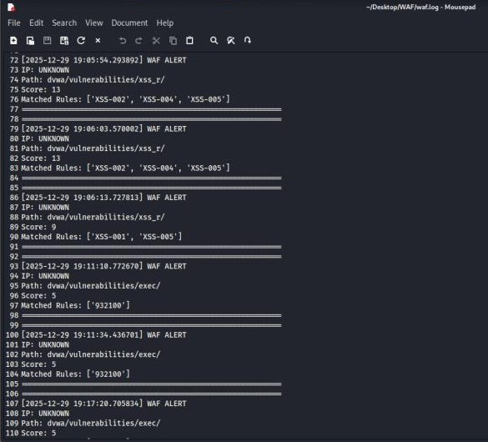
Figure 16. waf.log alert entries: timestamps, path, score and matched rules.
# | Timestamp (UTC log time) | Path | Score | Matched rules
1 | 2025-12-29 19:05:54 | xss_r | 13 | XSS-002, XSS-004, XSS-005
2 | 2025-12-29 19:06:03 | xss_r | 13 | XSS-002, XSS-004, XSS-005
3 | 2025-12-29 19:06:13 | xss_r | 9 | XSS-001, XSS-005
4 | 2025-12-29 19:11:10 | exec | 5 | 932100
5 | 2025-12-29 19:11:34 | exec | 5 | 932100
6 | 2025-12-29 19:17:20 | exec | 5 | (list cut off at screen edge)

What the log tells an analyst. Three XSS attempts in 19 seconds, followed by command-injection probes minutes later, is the pattern of a person working through an attack checklist. Stacked XSS rules (three matching at once) produce higher scores than a single command-injection rule, which is how anomaly scoring ranks severity. Rule 932100 follows the numbering of the OWASP Core Rule Set remote-command-execution group, suggesting the signature is derived from that set.
What the log cannot tell an analyst. All six entries show IP: UNKNOWN, so the attacker cannot be attributed; and the entries are headed "WAF ALERT" without an explicit ALLOW or BLOCK action, so a score-5 event cannot be confirmed as blocked from the log alone (F-06).

7.4 Findings and AWS WAF Mapping
ID | Finding | Evidence | Rating | Remediation
F-06 | Log records client IP as UNKNOWN and has no action field, limiting attribution and blocked-versus-allowed analysis. | Fig 16 | Medium | Read REMOTE_ADDR or a trusted X-Forwarded-For; add action, method, status and request-ID fields; ship logs off-host.
F-07 | WAF was validated in a local VMware lab on a private address, not attached to the AWS web tier. | Fig 13 | Medium | Attach AWS WAF to an Application Load Balancer or CloudFront (mapping below).

Defence in depth. The file-inclusion module (Figure 17) loads normally and reports that allow_url_include is not enabled in PHP, which independently prevents remote file inclusion. A WAF rule and a hardened runtime setting protect the same weakness at two layers. No file-inclusion attack was blocked in the evidence, so none is claimed.
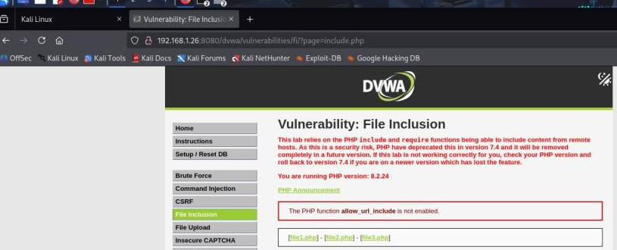
Figure 17. DVWA file-inclusion module baseline: allow_url_include is not enabled (PHP 8.2.24).
Moving the pattern to AWS. The custom proxy proves the logic; AWS WAF delivers it as a managed service. AWS WAF attaches to an Application Load Balancer, CloudFront, API Gateway and similar services, not directly to an EC2 instance, so an ALB would be placed in front of the web tier. An internet-facing ALB needs subnets in at least two Availability Zones, which the current single-AZ VPC does not yet have (F-12).
Custom WAF capability | AWS WAF equivalent (proposed) | Note
SQL injection rules | AWSManagedRulesSQLiRuleSet | Start in Count mode, review, then Block.
XSS and generic LFI/RFI | AWSManagedRulesCommonRuleSet | Covers OWASP Top 10 style issues.
Command and PHP injection | AWSManagedRulesPHPRuleSet; AWSManagedRulesLinuxRuleSet | Match the DVWA (PHP on Linux) stack.
Anomaly threshold | Rule actions plus rate-based rule | Rate-based rule limits request floods per IP.
Method validation | Method match rule | Allow only GET and POST where appropriate.
waf.log | WAF logging to CloudWatch Logs or S3 | Includes client IP, action and terminating rule.

8. Task 5: Multi-Region Backup and Recovery
Status: Designed, not executed
No screenshot shows a backup vault, plan, copy job or restore. This section is a complete design and runbook so the control can be implemented and verified; it is deliberately not presented as completed work.

Why multi-region. A backup stored in the same region and account as production fails with it: a regional outage, a compromised administrator or ransomware that deletes recovery points can remove every copy. A second, access-separated copy in another region implements the 3-2-1 principle (three copies, two media types, one off-site) and supports ISO/IEC 27001 controls A.8.13 (information backup), A.8.14 (redundancy) and A.5.30 (ICT readiness for continuity).

8.1 Design
Design item | Choice | Rationale
Primary and DR region | eu-north-1 to eu-west-1 (Ireland) | Geographic separation; both in the EU region group.
Mechanism | AWS Backup plan with a cross-region copy action | Central policy, job history and alerts.
Scope | EBS volumes tagged Backup=true | Tag-based selection avoids forgotten resources.
Schedule and retention | Daily 01:00 UTC; 35 days primary, 90 days DR | Covers weekly and monthly recovery needs.
Encryption | Customer-managed KMS key in each region (AES-256) | Keys controlled by the account; separate per region.
Immutability | AWS Backup Vault Lock, governance then compliance mode | Prevents deletion of recovery points, even by admins.
Targets (proposed) | RPO 24 hours; RTO 4 hours | Daily backups imply 24 hours; to be validated by a timed restore.

A tighter RPO is possible with hourly schedules or continuous backup for services that support it. The RTO and RPO above are targets until a restore exercise measures them.

8.2 Implementation Runbook
Step | Action | Where | Evidence to capture
1 | Create a KMS key in each region (alias shieldsafe-backup); enable rotation | KMS > Customer managed keys | Key policy and rotation status
2 | Create vaults ShieldSafe-Vault-Primary and ShieldSafe-Vault-DR with those keys | AWS Backup > Vaults | Both vaults and their keys
3 | Create plan ShieldSafe-Daily-CrossRegion with a copy rule to the DR vault | AWS Backup > Plans (JSON in Appendix B) | Rule page showing destination
4 | Assign resources by tag Backup=true | Plan > Resource assignments | Assigned EBS volumes
5 | Run an on-demand backup and confirm the copy job | Jobs > Backup jobs, Copy jobs | Status Completed in both regions
6 | Apply Vault Lock in governance mode; move to compliance mode after testing | Vault > Vault lock | Lock status and retention limits
7 | Send job failures to an SNS topic | Vault notifications | Confirmed subscription
8 | Restore from the DR vault and validate | Recovery points > Restore | Completed restore job and hash match

8.3 Restore Validation
A backup that has never been restored is an assumption. Validation uses SHA-256 so that integrity is proven, not inferred.
- Before backup: record sha256sum for critical files (web root, configuration) with file name, hash, timestamp and operator.
- After restore in the DR region: recompute the hashes and compare. The acceptance criterion is a 100% match; any mismatch triggers investigation and a fresh restore from an earlier recovery point.
- Time the exercise: record the interval from restore request to a responding, validated service. This is the measured RTO.
- Repeat monthly and after any change to the backup plan; keep the records as audit evidence.

ID | Finding | Evidence | Rating | Remediation
F-03 | No cross-region backup, copy job or restore test is evidenced. | None (gap) | High | Execute the runbook; retain screenshots and the SHA-256 comparison as evidence.

9. Task 6: Logging, Monitoring and Data Sources
Purpose. Decide what the audit trail is, what was actually used in this assignment, and what must be monitored. The brief lists AWS CloudTrail, Azure Monitor and GCP Logging as data sources. Because AWS was the audited platform, CloudTrail is the relevant source.
Data source | Used here? | How it was used or why not
WAF log (waf.log) | Yes | Analysed in Section 7.3 (Figure 16).
AWS CloudTrail | Mapped only | Expected events are mapped below; no event export is included.
Azure Monitor / GCP Logging | No | Azure and GCP were not part of the audited environment.
AWS Open Data | No | No analytics task required it; a possible extension for log-analysis practice.

9.1 Event-to-Evidence Mapping
Every action shown in the screenshots is an API call, so CloudTrail management events record it. The table lists the events each action would generate. Management events from the previous 90 days are viewable in CloudTrail Event history without extra configuration, so these can be verified directly. IAM is a global service; its events appear in the N. Virginia (us-east-1) history.
Action in this report | Expected CloudTrail eventName | Event source | Figure
Create VPC, subnets, route tables, internet gateway | CreateVpc, CreateSubnet, CreateRouteTable, CreateInternetGateway, AttachInternetGateway | ec2 | 3, 4
Create IAM groups | CreateGroup | iam | 5, 7
Attach AdministratorAccess to group | AttachGroupPolicy | iam | 6, 7
Create users with console password | CreateUser, CreateLoginProfile, AddUserToGroup | iam | 8, 9
Create key pair | CreateKeyPair | ec2 | 10
Create security group | CreateSecurityGroup | ec2 | 11

9.2 Monitoring Plan
Logging without alerting is a record of how an incident happened. The plan below turns the highest-risk events into notifications. All detections are proposed.
Detection | Source | Trigger | Response
Root account use | CloudTrail, metric filter | userIdentity.type = Root | Immediate review by security owner
Console sign-in without MFA | CloudTrail | ConsoleLogin with MFAUsed = No | Contact user; enforce MFA
IAM policy change | CloudTrail | AttachGroupPolicy, PutUserPolicy | Review within 24 hours
SSH opened to the internet | CloudTrail or AWS Config | Port 22 rule with 0.0.0.0/0 | Notify and revert
Backup job failure | AWS Backup, SNS | Job state Failed | Re-run; escalate after two failures
WAF block spike | WAF log | Many blocks per source in 5 minutes | Rate-limit or block the source

ID | Finding | Evidence | Rating | Remediation
F-05 | No multi-region CloudTrail trail, CloudWatch alarms or flow logs are evidenced beyond default Event history. | None (gap) | Medium | Create an organisation or account trail (all regions) to a protected S3 bucket with log-file validation; add the alarms above.

10. Consolidated Findings and Risk Register
Findings from Tasks 1 to 6 are consolidated below. Each is scored by likelihood and impact (Section 2.2). Three are High, six Medium and three Low.

Strengths observed
- S-1 Dedicated VPC with public and private subnets and a default route only on the public route table.
- S-2 Permissions assigned through IAM groups rather than directly to users.
- S-3 Auto-generated console passwords with forced reset at first sign-in.
- S-4 WAF blocked boolean and UNION SQL injection and reflected XSS while a benign request succeeded.
- S-5 WAF logs record rule IDs and anomaly scores for each alert.
- S-6 Remote file inclusion is additionally limited by PHP’s allow_url_include being disabled.

ID | Finding | L | I | Score | Rating | Task / remediation owner
F-01 | AdministratorAccess on both IAM groups | 3 | 5 | 15 | High | Task 2 / IAM administrator
F-02 | MFA not evidenced for any identity | 3 | 5 | 15 | High | Task 2 / IAM administrator
F-03 | No cross-region backup or restore test | 3 | 4 | 12 | High | Task 5 / platform owner
F-04 | Web security group has no scoped inbound rules | 3 | 3 | 9 | Medium | Task 3 / network engineer
F-05 | No multi-region trail, alarms or flow logs | 3 | 3 | 9 | Medium | Tasks 1, 6 / security team
F-06 | WAF log lacks client IP and action field | 4 | 2 | 8 | Medium | Task 4 / WAF owner
F-07 | WAF not attached to the AWS web tier | 3 | 3 | 9 | Medium | Task 4 / platform owner
F-08 | No HTTPS listener evidenced | 3 | 3 | 9 | Medium | Task 3 / network engineer
F-12 | Single Availability Zone deployment | 2 | 4 | 8 | Medium | Task 1 / platform owner
F-09 | Overlapping administrator groups | 2 | 2 | 4 | Low | Task 2 / IAM administrator
F-10 | Private subnet egress and patching path undefined | 2 | 2 | 4 | Low | Task 1 / network engineer
F-11 | Key pair storage and rotation not defined | 1 | 3 | 3 | Low | Task 3 / system administrator
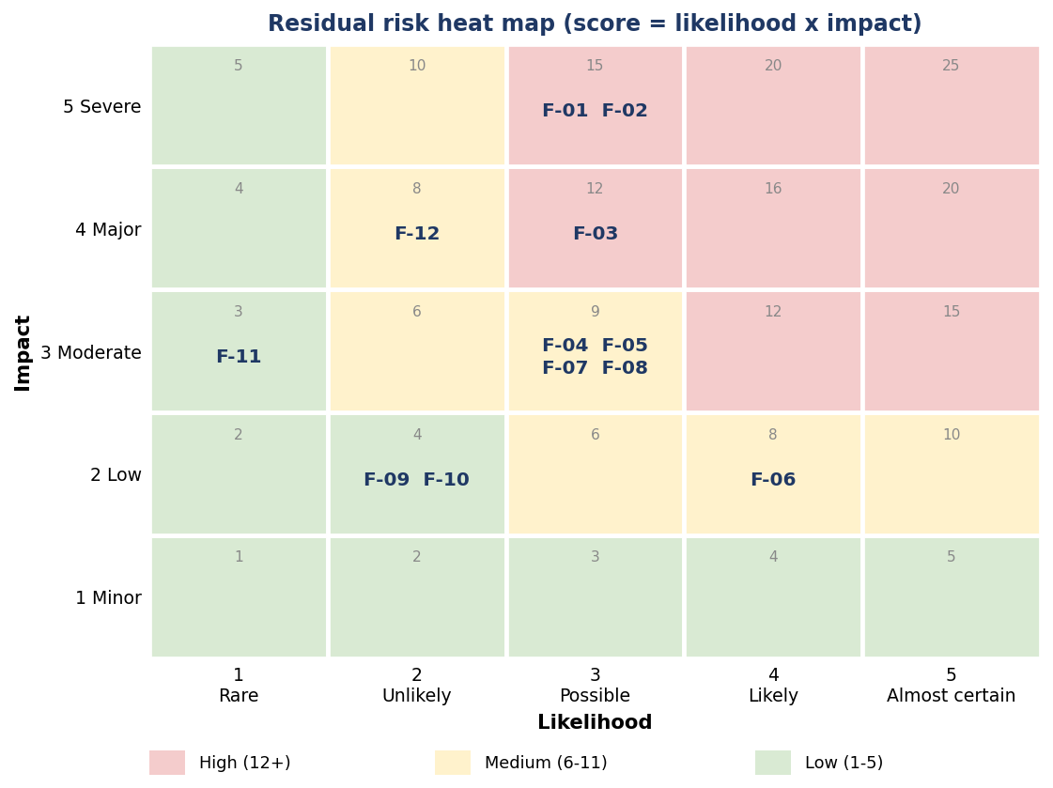
Figure 18. Risk heat map of the twelve findings.
The High cluster at likelihood 3 shows that the exposure comes from missing controls, not from active compromise. All three High findings are closed by configuration work that takes hours, not weeks, which is why the roadmap in Section 12 front-loads them.

11. Compliance Mapping
The table maps each control area to ISO/IEC 27001:2022 Annex A and to NIST Cybersecurity Framework 2.0 categories, showing how the technical work supports a management-system view of security.
Control area | Findings | ISO/IEC 27001:2022 Annex A | NIST CSF 2.0 | Status
Least-privilege access | F-01, F-09 | A.5.15, A.5.18, A.8.2 | PR.AA | Partially evidenced
Strong authentication (MFA) | F-02 | A.8.5 | PR.AA | Gap
Network segmentation | F-10, F-12 | A.8.20, A.8.22 | PR.IR | Evidenced
Traffic filtering and encryption | F-04, F-08 | A.8.20, A.8.24 | PR.IR, PR.DS | Partially evidenced
Web application protection | F-06, F-07 | A.8.26 | PR.PS, DE.CM | Evidenced
Logging and monitoring | F-05, F-06 | A.8.15, A.8.16 | DE.CM, DE.AE | Partially evidenced
Backup and recovery | F-03 | A.8.13, A.8.14, A.5.30 | PR.DS, RC.RP | Designed, not executed
Configuration and asset inventory | Tasks 1 to 3 | A.8.9 | ID.AM, ID.RA | Evidenced

The CIS Amazon Web Services Foundations Benchmark and the AWS Well-Architected Security Pillar were used as practitioner checklists for IAM, logging and networking. The mapping above is by control intent and should be confirmed against the organisation’s own Statement of Applicability before certification use.

12. Remediation Roadmap
Actions are sequenced by risk reduction per unit of effort. The first phase closes every High finding except the backup exercise, which needs a short build-and-test cycle.
Phase | Actions | Closes | Owner
Days 0 to 30 | Enable MFA on root and all users; replace AdministratorAccess with scoped policies and a permissions boundary; add restricted security-group rules and remove open SSH; start a multi-region CloudTrail trail; fix WAF client-IP and action logging. | F-01, F-02, F-04, F-05, F-06 | IAM and network teams
Days 31 to 60 | Run the cross-region backup runbook and a timed restore with SHA-256 validation; add subnets in a second AZ; terminate TLS on an ALB; enable VPC flow logs and the alarm set in Section 9.2. | F-03, F-08, F-12, F-05 | Platform owner
Days 61 to 90 | Attach AWS WAF with managed rule groups to the ALB (Count, then Block); add VPC endpoints or NAT for patching; move administration to Session Manager; start quarterly access reviews. | F-07, F-10, F-11, F-09 | Security team

Success measures
- 100% of privileged identities protected by MFA; no AdministratorAccess in day-to-day groups.
- Restore test completed with a 100% SHA-256 match and a measured RTO of four hours or less.
- Every security-group change and IAM policy change generates an alert reviewed within 24 hours.
- WAF logs carry client IP and action for 100% of events and are retained for at least 90 days.

13. Limitations and Evidence Statement
- Screenshot-based assessment. Findings reflect configuration visible at capture time. The WAF lab was captured on 29 to 30 December 2025 and the AWS console screens on later dates, so the two parts were not observed simultaneously.
- Multiple console sessions. The regional baseline (Figure 2) comes from a separate console session from the ShieldSafe screens and is used for method, not merged counts.
- Not evidenced. MFA devices, security-group inbound rules, backup vaults and plans, CloudTrail event exports, VPC flow logs, and an AWS-managed WAF are not shown. They are reported as gaps or designs.
- Lab scope. The WAF ran on a private LAN address against DVWA; results show detection logic, not internet-scale performance. Attack payloads were sent only to systems owned for the exercise.
- Data sources. Azure Monitor, GCP Logging and AWS Open Data were not used because AWS was the audited platform.
- Proposed values. RTO, RPO, retention periods and rule sets are design proposals, to be validated by exercise.

14. Conclusion
The assignment asked for a cloud environment that follows industry-standard security measures. The work shows a sound foundation: a segmented VPC, group-based IAM, controlled credential issue, and a working web application firewall that blocked SQL injection and XSS while allowing legitimate use and recording each decision with rule IDs and scores.
The audit also shows why a foundation is not a finished control. Administrator rights are too broad, MFA is unproven, the web security group is not yet scoped, a single Availability Zone carries every tier, and the recovery and monitoring layers exist as designs rather than demonstrated controls. Each gap is rated, mapped to ISO/IEC 27001 and NIST CSF 2.0, and given an owner and a 90-day plan.
The most valuable outcome is the separation of three things that are easily confused: what was shown to work, what was designed but not run, and what is still missing. That separation is what lets a reviewer trust the report, and it gives Internee.pk a precise list of what to do next.

References
Amazon Web Services (n.d.) AWS Backup Developer Guide. Available at: https://docs.aws.amazon.com/aws-backup/latest/devguide/whatisbackup.html
Amazon Web Services (n.d.) AWS CloudTrail User Guide. Available at: https://docs.aws.amazon.com/awscloudtrail/latest/userguide/cloudtrail-user-guide.html
Amazon Web Services (n.d.) AWS WAF Developer Guide. Available at: https://docs.aws.amazon.com/waf/latest/developerguide/waf-chapter.html
Amazon Web Services (n.d.) Security best practices in IAM. Available at: https://docs.aws.amazon.com/IAM/latest/UserGuide/best-practices.html
Amazon Web Services (n.d.) Amazon VPC User Guide. Available at: https://docs.aws.amazon.com/vpc/latest/userguide/what-is-amazon-vpc.html
Amazon Web Services (n.d.) AWS Well-Architected Framework: Security Pillar.
Center for Internet Security (n.d.) CIS Amazon Web Services Foundations Benchmark.
International Organization for Standardization (2019) ISO 22301:2019 Security and resilience: Business continuity management systems: Requirements. Geneva: ISO.
International Organization for Standardization (2022) ISO/IEC 27001:2022 Information security, cybersecurity and privacy protection: Information security management systems: Requirements. Geneva: ISO.
National Institute of Standards and Technology (2006) SP 800-92: Guide to Computer Security Log Management. Gaithersburg, MD: NIST.
National Institute of Standards and Technology (2010) SP 800-34 Rev. 1: Contingency Planning Guide for Federal Information Systems. Gaithersburg, MD: NIST.
National Institute of Standards and Technology (2024) The NIST Cybersecurity Framework (CSF) 2.0. Gaithersburg, MD: NIST.
OWASP Foundation (2021) OWASP Top 10:2021. Available at: https://owasp.org/Top10/
OWASP Foundation (n.d.) OWASP Core Rule Set. Available at: https://coreruleset.org/
Wood, R. (n.d.) Damn Vulnerable Web Application (DVWA). Available at: https://github.com/digininja/DVWA

Appendix A: Evidence Index
Each figure, the environment it came from and the findings it supports. Account identifiers were redacted from Figures 4, 5, 6, 9 and 11, and from Figure 2.
Fig. | Content | Environment | Supports
1 | Architecture diagram (author-prepared) | Design | Sections 3, 7, 8
2 | VPC dashboard, regional resource counts | AWS console | Task 1, F-10
3 | VPC creation preview: CIDR, subnets, routes | AWS console | S-1, F-10, F-12
4 | ShieldSafe-vpc details and resource map | AWS console | S-1, F-05, F-12
5 | Create user group ShieldSafe-SecOps-Team | AWS console | F-09
6 | Set permissions: add user to group, AdministratorAccess shown | AWS console | F-01, F-09, S-2
7 | Create ShieldSafe-Migration-Admins with AdministratorAccess | AWS console | F-01
8 | Review user shieldsafe-admin; forced password reset | AWS console | S-3, F-02
9 | User created; credential retrieval for shieldsafe-cloudsec | AWS console | S-3, F-02
10 | Create key pair (RSA, .pem) | AWS console | F-11
11 | ShieldSafe-Web-SG with empty inbound rules | AWS console | F-04, F-08
12 | Benign request allowed (id=1) | WAF lab | S-4
13 | Boolean SQL injection blocked | WAF lab | S-4
14 | UNION SQL injection blocked | WAF lab | S-4
15 | Reflected XSS blocked | WAF lab | S-4
16 | waf.log alert entries | WAF lab | S-5, F-06
17 | File-inclusion module baseline | WAF lab | S-6, F-07
18 | Risk heat map (author-prepared) | Analysis | Section 10

Appendix B: Reference Policies and Backup Plan
These are illustrative designs for the proposed controls. They have not been applied to the environment shown in the figures and must be tested in a sandbox account before use. Replace placeholders such as the account ID.

Policy 1: Scoped deployment policy (replaces AdministratorAccess on ShieldSafe-Migration-Admins)
{
"Version": "2012-10-17",
"Statement": [
{
"Sid": "DeployInApprovedRegions",
"Effect": "Allow",
"Action": [
"ec2:Describe*",
"ec2:RunInstances",
"ec2:StartInstances",
"ec2:StopInstances",
"ec2:CreateTags",
"ec2:CreateSecurityGroup",
"ec2:AuthorizeSecurityGroupIngress",
"ec2:CreateKeyPair"
],
"Resource": "*",
"Condition": {
"StringEquals": {
"aws:RequestedRegion": [
"eu-north-1",
"eu-west-1"
]
}
}
},
{
"Sid": "ReadOnlyAudit",
"Effect": "Allow",
"Action": [
"cloudtrail:LookupEvents",
"iam:Get*",
"iam:List*",
"cloudwatch:Get*",
"logs:Describe*"
],
"Resource": "*"
},
{
"Sid": "DenyPrivilegeEscalation",
"Effect": "Deny",
"Action": [
"iam:CreateUser",
"iam:CreateAccessKey",
"iam:AttachUserPolicy",
"iam:AttachGroupPolicy",
"iam:PutUserPolicy",
"iam:PutGroupPolicy"
],
"Resource": "*"
}
]
}

Policy 2: Deny actions without MFA (attach to all human groups)
{
"Version": "2012-10-17",
"Statement": [
{
"Sid": "AllowSelfServiceMFA",
"Effect": "Allow",
"Action": [
"iam:CreateVirtualMFADevice",
"iam:EnableMFADevice",
"iam:ResyncMFADevice",
"iam:ListMFADevices",
"iam:ChangePassword",
"iam:GetUser"
],
"Resource": [
"arn:aws:iam::*:user/${aws:username}",
"arn:aws:iam::*:mfa/${aws:username}"
]
},
{
"Sid": "AllowListVirtualMFA",
"Effect": "Allow",
"Action": "iam:ListVirtualMFADevices",
"Resource": "*"
},
{
"Sid": "DenyAllExceptMFASetupWithoutMFA",
"Effect": "Deny",
"NotAction": [
"iam:CreateVirtualMFADevice",
"iam:EnableMFADevice",
"iam:ResyncMFADevice",
"iam:ListMFADevices",
"iam:ListVirtualMFADevices",
"iam:ChangePassword",
"iam:GetUser",
"sts:GetSessionToken"
],
"Resource": "*",
"Condition": {
"BoolIfExists": {
"aws:MultiFactorAuthPresent": "false"
}
}
}
]
}

Plan 3: AWS Backup plan with cross-region copy
{
"BackupPlanName": "ShieldSafe-Daily-CrossRegion",
"Rules": [
{
"RuleName": "Daily-35d-with-DR-copy",
"TargetBackupVaultName": "ShieldSafe-Vault-Primary",
"ScheduleExpression": "cron(0 1 * * ? *)",
"StartWindowMinutes": 60,
"CompletionWindowMinutes": 180,
"Lifecycle": {
"DeleteAfterDays": 35
},
"CopyActions": [
{
"DestinationBackupVaultArn":
"arn:aws:backup:eu-west-1:<ACCOUNT_ID>:backup-vault:ShieldSafe-Vault-DR",
"Lifecycle": {
"DeleteAfterDays": 90
}
}
]
}
]
}

